CHAPTER 3: PROJECT METHODOLOGY
This chapter presents the methodology and system architecture designed to solve the three core research objectives of this project: (PO1) translating qualitative biographical assessments into continuous narrator reliability scores, (PO2) constructing a multi-relational Knowledge Graph with structural representation learning, and (PO3) verifying chain-level authenticity against classical scholarly gradings.
The developed pipeline transitions from raw texts to structured predictions through three distinct phases: (1) Data Ingestion and Preprocessing, (2) Knowledge Graph Construction and Node Alignment, and (3) Probabilistic Trust Scoring, Graph Neural Network (GNN) structural learning, and Chain-Level Soft Aggregation.

3.1 Research Design
This study adopts an experimental research design utilising the Design Science Research Methodology (DSRM). The central artifact is a multi-modal computational pipeline that models both the textual sentiment of classical biographical evaluations (biographical criticism or ʿIlm al-Jarḥ wa-t-Taʿdīl) and the structural topology of transmission chains (isnād networks). The complete framework architecture is illustrated in Figure 3.1.

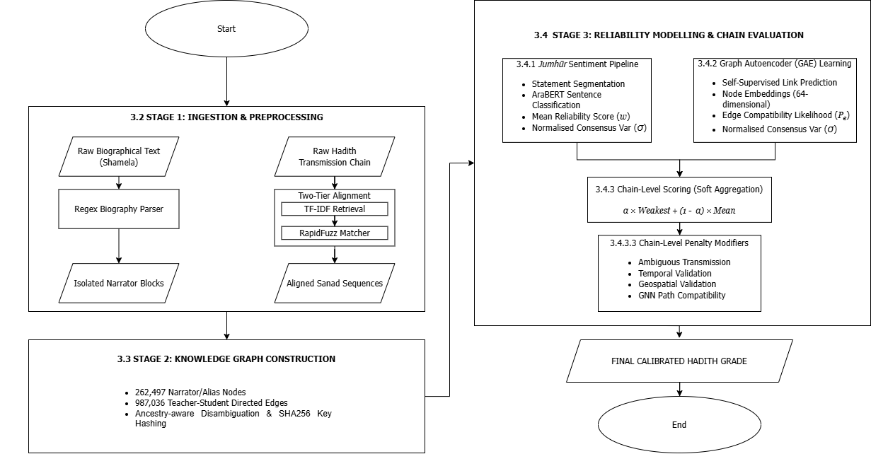
Figure 3.1: Flowchart of the Multi-Modal Hadith Authenticity Verification Pipeline

3.2 Stage 1: Data Ingestion and Preprocessing

3.2.1 Data Sources
The framework integrates structured transmission data with unstructured biographical judgments:
- Biographical Corpora: Sourced from the Shamela Digital Library, targeting Ibn Hajar al-Asqalani's Taqrīb al-Tahdhīb and al-Mizzi's Tahdhīb al-Kamāl. These serve as the basis for extracting consensus textual judgments.
- Transmission Corpora: Built upon the Sanadset 650K dataset, which provides 650,986 Hadith chains, mapped against four evaluation dataset parameters across two targeted alignment benchmarks (1,200 and 6,000 successfully aligned Hadiths) and two balancing strategies (Book-Balanced and Grade-Balanced). To ensure target alignment goals are achieved despite Levenshtein quarantine filtering, fixed pre-alignment sampling targets of 1,800 and 7,000 query Hadiths are drawn from HuggingFace datasets with canonical grades (e.g., Ṣaḥīḥ, Ḍaʿīf, Ḥasan).

3.2.2 Biographical Text Parsing and Block Extraction
Raw texts are preprocessed using a custom Regular Expression (Regex) parser. The parser identifies structured markup (e.g., # $Tarjama tags) and entry delimiters, isolating independent text blocks for each narrator. It filters out metadata headers, page numbers, and publisher footnotes to yield clean, consonantal Arabic skeletons for analysis.

3.2.3 Two-Tiered Algorithmic Alignment Framework
To link transmission chains to biographical entries without a shared index, the system implements a two-tiered alignment pipeline:
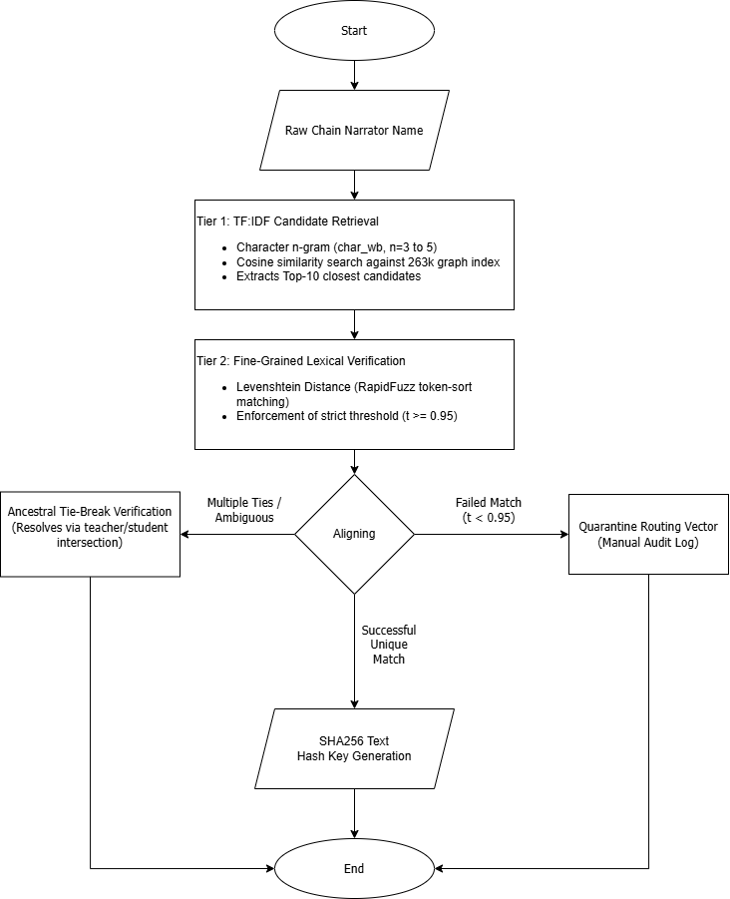
Figure 3.2: Two-Tiered Algorithmic Alignment Architecture
- Tier 1: Heuristic Search Space Reduction (Information Retrieval Layer): Computes TF-IDF vectors using character-level $n$-grams ($n∈\left[3,5\right]$) on normalised text. This isolates a candidate pool of the top 10 matches for any input query out of the 262k entries, bypassing computational bottlenecks.
- Tier 2: Fine-Grained Lexical Verification (Fuzzy Matching Layer): Applies token-sort Levenshtein distance calculations via the RapidFuzz library to select the optimal candidate. Matches must exceed a strict similarity threshold ($t≥0.95$).
- Ancestral Node Tie-Breaking: When multiple candidates yield identical fuzzy ratios, the algorithm resolves the tie-break by checking the immediate predecessor and successor nodes (the narrator's teachers and students) against the biographical network.
- SHA256 Identity Preservation: Aligned entities are assigned an immutable, unique primary key calculated as a SHA-256 hash of their normalised Arabic consonantal skeleton.
- Quarantine Routing: Records failing to meet the fuzzy matching threshold or showing irreconcilable network overlaps are routed to a JSON quarantine log for manual scholar-in-the-loop audit.

3.3 Stage 2: Knowledge Graph Construction

3.3.1 Relational Graph Dimensions
Rather than utilising a small sample, the system builds a comprehensive Knowledge Graph (KG) mapping the historical transmission network. The dimensions of the constructed graph are detailed in Table 3.1.

Table 3.1: Dimensions of the Constructed Relational Knowledge Graph
Graph Entity / Relation | Actual Count
Total Graph Nodes | 262,497
Total Graph Edges | 987,036
Narrator Encyclopaedia Entries | 15,448
Alternative Aliases | 24,545
Inter-Narrator Family Links | 13,592

3.3.2 Node & Edge Attribute Representation
Each narrator node is populated with rich attributes extracted from classical literature:
- Tabaqa (Generation): Coded as an integer range from 1 to 12 matching Ibn Hajar's temporal classification (ranging from the Ṣaḥāba [Companions, ~1st Century AH] to late compilers [~3rd Century AH]).
- Geographic Travel Regions: Categorised lists of historically visited cities (e.g., Medina, Kufa, Basra, Damascus, Baghdad, Cordoba).
- Relational Edges: Directed connections mapping teacher-to-student propagation ($u→v$).

3.3.3 Algorithmic Name Mapping (Alias & Ancestry Matcher)
Due to the absence of trained Named Entity Recognition (NER) models with verified entity-level F1 metrics in this domain, narrator boundary parsing is executed via heuristic token extraction, index matching, and alias resolution. This maps narrator chains directly to the canonical node database. Token classification via fine-tuned Transformer-based NER models (AraBERT sequence labelling) is demoted to future work.

3.4 Stage 3: Probabilistic Trust Scoring and Evaluation

3.4.1 Semantic Sentiment Analysis for Continuous Reliability Scoring
Instead of assigning binary weights, the framework implements a multi-tiered Jumhūr Sentiment Aggregation pipeline to estimate narrator reliability. This models the differences of opinion among classical critics (Jumhūr or consensus) as a continuous scoring task.
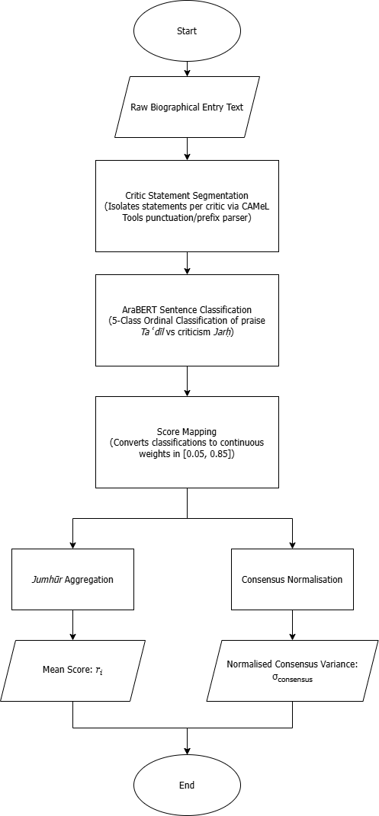
Figure 3.3: Multi-Tiered Jumhūr Sentiment Aggregation Pipeline
- Critic Statement Segmentation: Extracts individual evaluative statements using Arabic punctuation patterns and scholar-specific prefix indicators (e.g., قال أحمد, “Ahmad said”).
- AraBERT Sentence-Level Classification: Predicts the sentiment of each statement using an AraBERT-based classifier pre-trained on Arabic sentiment data. To model narrator reliability from evaluative biographical statements, the system formulates the task as discrete ordinal classification rather than direct continuous regression. In qualitative NLP tasks, a common limitation known as Deep Imbalanced Regression (DIR) is where continuous regression objectives frequently suffer from severe score compression and regression toward the empirical mean when predicting unbounded numerical values across skewed qualitative classes (Yang et al., 2021). By formulating the task as a 5-class ordinal classification problem (matrūk, ḍaʿīf, maqbūl, ṣadūq, thiqa), the architecture enforces crisp decision boundaries between quality bands before mapping predictions to continuous ordinal score weights [0.05, 0.85].
- Score Mapping: Translates raw sentiment predictions into ordinal class scores ranging from 0.05 (severely weak / matrūk) to 0.85 (highly reliable / thiqa). This ceiling of 0.85 represents the inherent historical uncertainty of human transmission; classical Hadith criticism is fundamentally a via negativa process focusing on defect detection, meaning no narrator is modeled with absolute mathematical certainty (1.0). Ultra-high terms (Thābit, Ḥāfiẓ, Imām) under Class 4 and severe defects (Waddāʿ, Dajjāl) under Class 0 are grouped to prevent the AraBERT model from suffering from data sparsity issues. The mapping of qualitative scholarly judgments to numerical values and their classical Arabic synonyms is detailed in Table 3.2:
Table 3.2: Semantic Score Mapping and Classical Arabic Synonyms for Biographical Tiers
Model Quality Tier | Classical Arabic Grade Synonyms | Sentiment Polarity | Numeric Score Mapping ($s_{i}$) | Academic Explanation
Thiqa (Class 4) | ثقة, ثقة ثقة, ثقة ثبت, ثقة حافظ, ثقة متقن, ثبت, حافظ, إمام, مأمون, صحابي | Taʿdīl (Praise) | $$0.85$$ | Maximum reliability tier for the textual semantic layer.
Ṣadūq (Class 3) | صدوق, لا بأس به, ليس به بأس, محله الصدق | Taʿdīl (Praise) | $$0.70$$ | Truthful narrator but susceptible to minor errors.
Maqbūl (Class 2) | مقبول, صدوق يهم, صدوق سيء الحفظ, سيء الحفظ | Marginal / Neutral | $$0.40$$ | Acceptable only when supported by corroborating chains.
Ḍaʿīf (Class 1) | ضعيف, ضعيف الحديث, لين, لين الحديث, ليس بالقوي, فيه ضعف, مستور, مجهول الحال | Jarḥ (Criticism) | $$0.15$$ | Unreliable or weak narrator.
Matrūk (Class 0) | متروك, متروك الحديث, ساقط, مختلط, مجهول العين, كذاب, وضاع, دجال | Jarḥ (Criticism) | $$0.05$$ | Abandoned narrator (minimum baseline boundary).
- Jumhūr Aggregation: Computes the narrator's base semantic reliability score ($r_{i}$) as the mean of their individual statement scores:
$$r_{i}=\frac{1}{N}\sum_{i=1}^{N}{s_{i}}$$
- Consensus Score Calculation: Measures the variance of opinions for each narrator. To represent scholarly agreement on a normalised scale, the consensus score is calculated as:
$$\text{agreement_score}=1.0-\frac{\text{Var}\left(s\right)}{0.16}$$
Where the denominator ($0.16$) represents the maximum possible variance of a continuous score bounded on the interval $\left[0.05,0.85\right]$. The maximum variance occurs at a 50/50 split at the boundaries:
$${\text{Var}}_{max}={\left(\frac{0.85-0.05}{2}\right)}^{2}={\left(0.40\right)}^{2}=0.16$$

3.4.2 Unsupervised Graph Autoencoders (GAE) for Structural Representation Learning
Instead of attempting to predict narrator grades directly from a supervised GNN (which suffers from label scarcity and introduces bias), the structural analysis component uses an unsupervised Graph Autoencoder (GAE).

3.4.2.1 GAE Architecture
The GAE encodes node structures into a latent space and reconstructs network topology using a link prediction objective:
- Encoder: A 2-layer Graph Convolutional Network (GCN) that takes node feature vectors $X$ and the adjacency matrix $A$ to compute 64-dimensional latent embeddings $Z$:
$$Z=\text{GCN}\left(X,A\right)$$
- Decoder: A simple inner product that reconstructs the link compatibility score ($P_{e}$) for any edge $\left(u,v\right)$:
$${\overset{ˆ}{A}}_{u,v}=σ\left(z_{u}^{T}z_{v}\right)$$
- Objective Function: The reconstruction loss is defined as binary cross-entropy on link existence:
$$L=-\sum_{\left(u,v\right)∈E}{\log\left(σ\left(z_{u}^{T}z_{v}\right))-\sum_{\left(u,v'\right)∉E}{\log\left(1-σ\left(z_{u}^{T}z_{v'}\right))\right)}\right)}$$
The GAE is trained for 200 epochs using the Adam optimiser (learning rate = $1×{10}^{-3}$, dropout = $0.3$). The model achieves robust link prediction performance on a 20% test split:
- ROC-AUC: 92.39%
- Average Precision (AP): 94.04%

3.4.2.2 GNN Uncertainty Modulation
The GNN embeddings modulate the narrator reliability score rather than overriding textual criticism. For a narrator with a marginal base score, the system checks their structural embedding. If the narrator exhibits high link compatibility ($P_{e}≥0.50$) and is well-integrated within reliable transmission paths, a GNN mitigation factor is applied to reduce their base weakness penalty by up to a maximum of 15%:
$$\text{effective_penalty}=\text{base_penalty}×\left(1-\text{GNN_mitigation}\right)$$

3.4.3 Chain-Level Scoring (Soft Aggregation)
The final authenticity score of a Hadith transmission chain ($S_{chain}$) is computed by combining modulated individual narrator reliability scores using a soft aggregation function, which is then adjusted by topological, geospatial, and temporal penalty modifiers.
For each narrator $i$ in a transmission chain of length $M$, the system first computes an individual modulated score $W_{i}$:
$$W_{i}=w_{i}×{\text{risk}}_{i}$$
where ${\text{risk}}_{i}∈\left[0.0,1.0\right]$represents narrator-specific risk modifiers. To extract these modifiers, a rule-based linguistic pattern-matching pipeline scans the normalised biographical text during the data preparation stage for classical Arabic root patterns representing specific transmission defects:
Table 3.3: Risk Modifier Multipliers with Description
Risk Modifier Type | Arabic Lexical Patterns | Multiplier | Technical Description
Concealed Weakness (tadlīs) | تدليس, مدلس, يدلس | $$0.80$$ | Narrator conceals their immediate teacher's identity using ambiguous terms.
Mental Deterioration (ikhtilāṭ) | مختلط, اختلط بآخره, تغير بآخره, تغير قبل | $$0.50$$ | Narrator suffered memory loss or cognitive decline in later life.
Identity Uncertainty (jahāla) | مجهول العين, مجهول الحال | $$0.30$$ | Narrator's status or reliability is unknown to biography compilers.
Fabrication (kadhib) | كذاب, يضع الحديث, وضاع, متهم بالكذب | $$0.00$$ | Narrator is accused of lying or deliberate fabrication (chain-breaking).
If a narrator's biography contains multiple defects, the system selects the most severe penalty by calculating the minimum modifier:
$${\text{risk}}_{i}=\min_{k}\left({\text{modifier}}_{k}\right)$$
If no defects are detected, the modifier defaults to ${\text{risk}}_{i}=1.0$.
The base narrator score $w_{i}$ combines their semantic reliability score $r_{i}$ with severity-band and consensus modulations:
$$w_{i}=r_{i}×d_{i}×d_{agree,i}$$
The variables in this calculation are defined as follows:
- Severity-Band Discount ($d_{i}$): Base discount factor mapped to narrator reliability ranges:
$$d_{i}=\left\{\begin{matrix}1.0 & \text{if }r_{i}≥0.80\text{ (}\text{Thiqa}\text{)} \\ 1.0 & \text{if }r_{i}≥0.70\text{ (}\text{Ṣadūq} \text{)} \\ 0.85 & \text{if }r_{i}≥0.40\text{ (}\text{Maqbūl} \text{)} \\ 0.60 & \text{if }r_{i}≥0.20\text{ (}\text{Ḍaʿīf} \text{)} \\ 0.25 & \text{if }r_{i}<0.20\text{ (}\text{Matrūk}\text{)}\end{matrix}\right.$$
- GNN Uncertainty Modulation: If a narrator falls into a Maqbūl or Ḍaʿīf category, but exhibits high structural integration in the GAE Knowledge Graph (indicated by a low GNN Anomaly Score $A_{i}<0.25$), a structural mitigation factor is applied to the discount:
$$d_{i}^{mitigated}=d_{i}+\left(1.0-d_{i}\right)×0.15$$
- Disagreement Risk Modifier ($d_{agree,i}$): Penalises narrators with high scholarly disputes (low consensus scores):
$$d_{agree,i}=1.0-0.20×\left(1.0-{\text{agreement_score}}_{i}\right)$$
where ${\text{agreement_score}}_{i}=1.0-\frac{\text{Var}\left(s\right)}{0.16}$ represents the consensus rating.

3.4.3.2 Base Chain Score ($S_{base}$)
Rather than multiplying narrator scores ($S_{chain}=\prod{W_{i}}$), which causes exponential score decay on longer chains, the pipeline uses a parameterised Soft Aggregation formula:
$$S_{base}=α×\min_{i}\left(W_{i}\right)+\left(1-α\right)×\left(\frac{1}{M}\sum_{i=1}^{M}{W_{i}}\right)$$
where $α∈\left\{0.25,0.50,0.75\right\}$ is empirically optimised to balance the weakest-narrator bottleneck with overall chain quality.

3.4.3.3 Chain-Level Penalty Modifiers
The base chain score is adjusted by multiplying three independent penalty factors:
- Ambiguous Transmission (ʿAnʿana) Penalty ($P_{amb}$): Applied if a narrator categorised as a Mudallis (known to practice tadlīs) transmits using the ambiguous particle عن (ʿan, “from”) instead of explicit direct audition (e.g., حدثنا, haddathana, “we narrated”).
- Temporal Validation (Inqitāʿ) Penalty ($P_{temp}$): Evaluates chronological feasibility between adjacent narrator generations (tabaqāt). If a teacher is younger than the student (chronological impossibility) or exhibits significant gaps, a broken transmission (inqitāʿ) is flagged:
$$P_{temp}=\left\{\begin{matrix}0.40 & \text{if severe gap (e.g., teacher }≥\text{ student }+5\text{ generations)} \\ 0.60 & \text{if moderate gap (e.g., teacher }≥\text{ student }+3\text{ generations)} \\ 1.0 & \text{otherwise}\end{matrix}\right.$$
- Geospatial Validation Penalty ($P_{geo}$): Compares travel paths between adjacent transmitters. If lifespans overlap but travel records show no plausible geographic intersection (distance between locations $>3,000$km), a distance penalty is applied:
$$P_{geo}=\prod_{j=1}^{M-1}{g_{j}}, \text{where }g_{j}=\left\{\begin{matrix}0.85 & \text{if distance }>3,000\text{ km} \\ 1.0 & \text{otherwise}\end{matrix}\right.$$
- GNN Path Compatibility Penalty ($P_{gnn}$): Uses the GAE link prediction scores to check structural continuity between adjacent nodes in the chain:
$$P_{gnn}=\left\{\begin{matrix}0.85 & \text{if }\min_{j}\left(σ\left(z_{j}^{T}z_{j+1}\right))<0.25\right) \\ 1.0 & \text{otherwise}\end{matrix}\right.$$

3.4.3.4 Final Chain Score ($S_{chain}$)
The final authenticated score is the product of the soft-aggregated base score and the edge penalty modifiers:
$$S_{chain}=S_{base}×P_{amb}×P_{temp}×P_{geo}×P_{gnn}$$
This continuous score is subsequently mapped to canonical grades (Ṣaḥīḥ, Ḥasan, Maqbul, Ḍaʿīf, Matrūk) using calibrated percentile thresholds.

3.4.4 Evaluation Protocol
The pipeline's grading accuracy is validated against classical Hadith classifications across multiple datasets at the following scales:
- 1,200 Aligned Benchmarks: Evaluated across Book-Balanced (300 per collection) and Grade-Balanced parameters using fixed pre-alignment sampling targets of 1,800 query Hadiths.
- 6,000 Aligned Benchmarks: Evaluated across Book-Balanced (~1,166 per collection) and Grade-Balanced parameters using fixed pre-alignment sampling targets of up to 7,000 query Hadiths (utilising all available graded records for grade-balanced sets).
- 435,000 Bulk Grading: Scale testing performed on 435,351 valid chains from the Sanadset corpus to analyze the overall score distribution.
The model maps the final continuous chain score to five ordinal classes: Ṣaḥīḥ (Authentic), Ḥasan (Good), Maqbul (Acceptable), Ḍaʿīf (Weak), and Matrūk (Abandoned). Threshold calibration is performed using percentile-matching rather than standard regression to prevent threshold collapse.

